  - 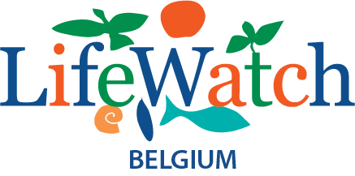

  - WoRMS Top-Ten Marine Species of 2023 Nomination form

The aim of this list is to highlight the fascinating discoveries of the numerous new marine species being made every year, to the wider public.

Like last year we again plan to release our list to coincide with World Taxonomist Appreciation day - March 19th! To make our decisions we need the same information for all species:

Name of nominator:

Name of Species (with authority):

Contact name and email of author/authors or a willing contact:

Is the name validly published and in WoRMS? Yes/No

Please provide Aphia ID/link:

Full citation of publication:

Is the publication open access? Yes/No

Attached a PDF of the publication? Yes/No

Image or link to image of the species:

Copyright/ownership information for image:

Why should this species be included in the Top-Ten for 2023?
Please provide us with information/a story explaining why your species should be chosen. Please do include links to other media about the species if these are available.

